**NAAN MUDHAVALVAN- SALESFORCE REPORT**

**A CRM APPLICATION TO MANAGE THE MALL**

**PROJECT CREATED BY**

**BE –V SEMESTER**

**Team Members: Register Number:**

ANANTHI D 421622104004

ARULSELVI S 421622104014

DIVYA K 421622104032

HEMALATHA P 421622104046

**DEPARTMENT OF COMPUTER SCIENCE AND ENGINEERING**

**MAILAM ENGINEERING COLLEGE**



**1.Project Overview:**

This project involves the development of a Customer Relationship Management (CRM) application tailored for mall management, leveraging the Salesforce platform for its robust features and scalability. The application is designed to manage tenants, leases, and issue tracking efficiently. It includes creating custom objects such as Tenant, Lease Tracking, and Tenant Issues, along with corresponding fields, relationships, and custom tabs.

**2.Objectives:**

The primary objective of this project is to design and implement a robust CRM application using the Salesforce platform to streamline mall management operations. The system aims to efficiently manage tenant information, lease agreements, and tenant issue tracking while providing actionable insights through reports and dashboards. By creating custom objects like Tenant, Lease Tracking, and Tenant Issues, the application ensures that all critical data points are captured and organized.

**3.Solution Design Steps for the Salesforce Mall Management CRM Application:**

* **Create Custom Objects:**

We should create a custom objects in salesforce, follow these details:

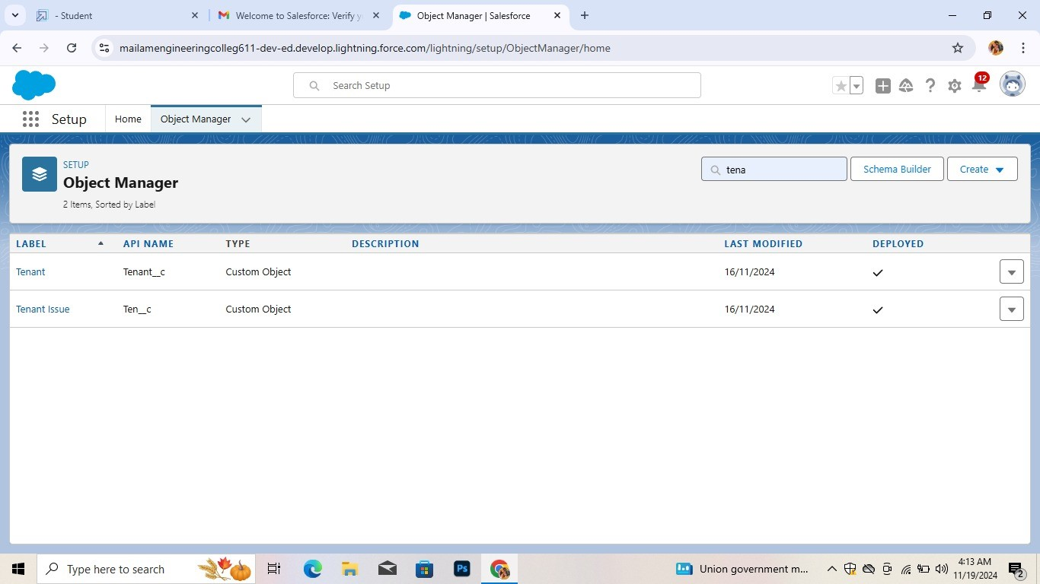

* **Create a Tabs:**

Overview of key metrics, such as footfall, sales data, and tenant performance.

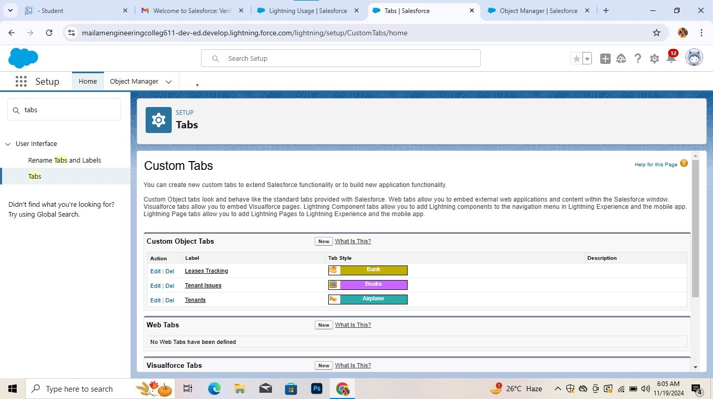

* **Create fields on tenant object:**

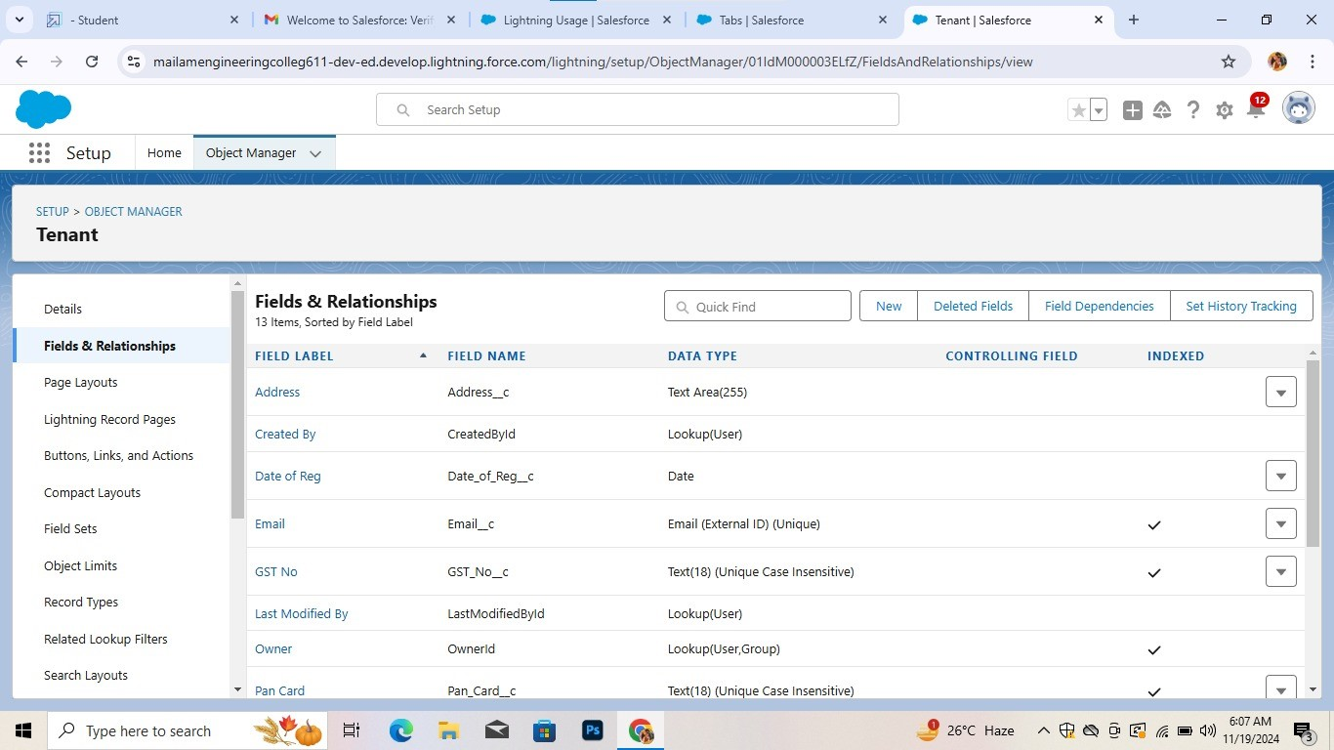

* **Create fields on Lease tracking object**:

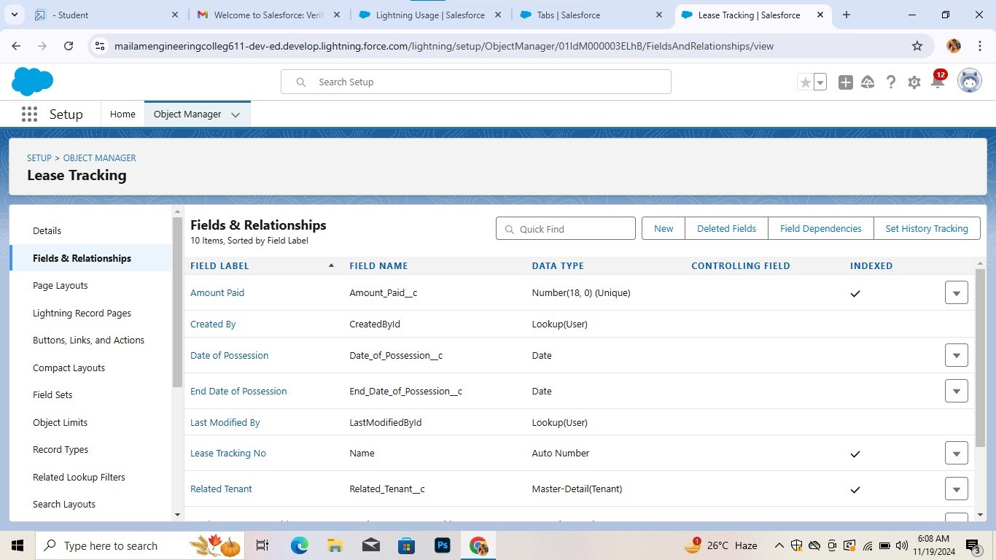

* **Create fields on tenant issues:**



* **Inserting records in tenant object:**

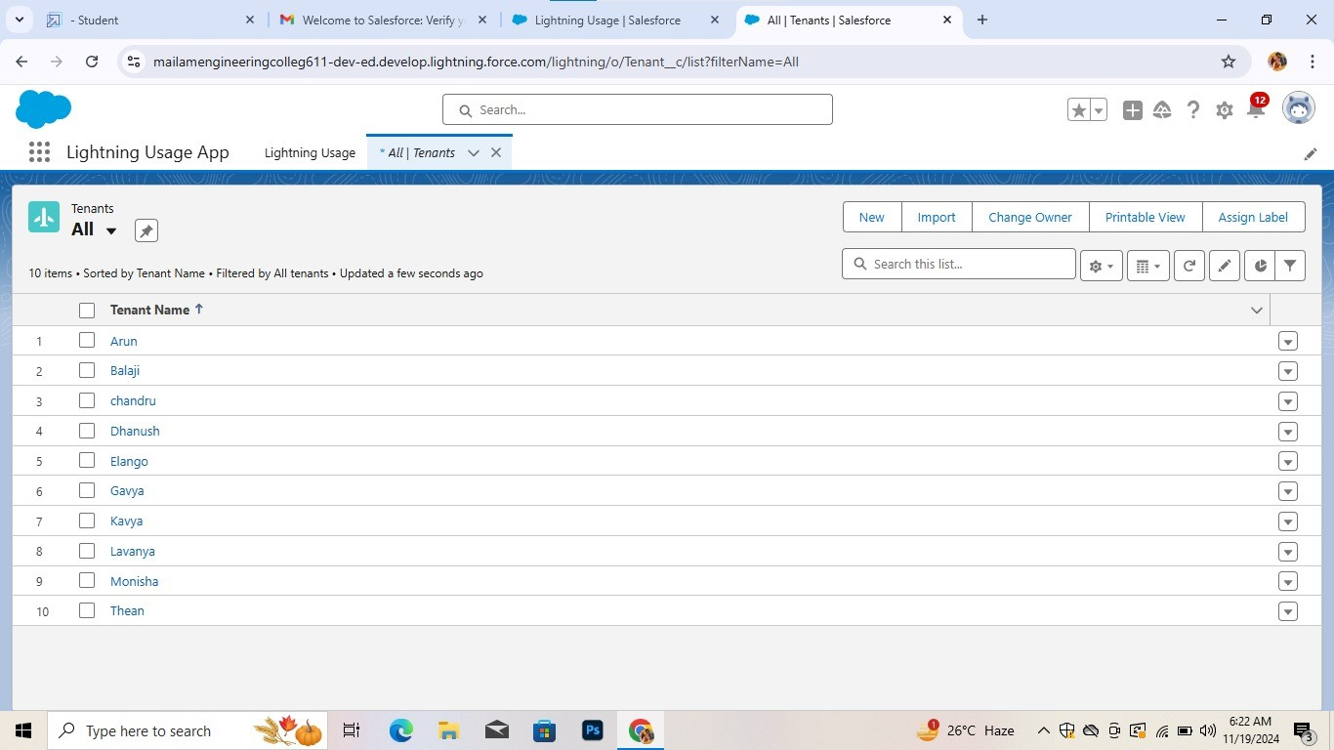

* **Inserting records in lease tracking object:**

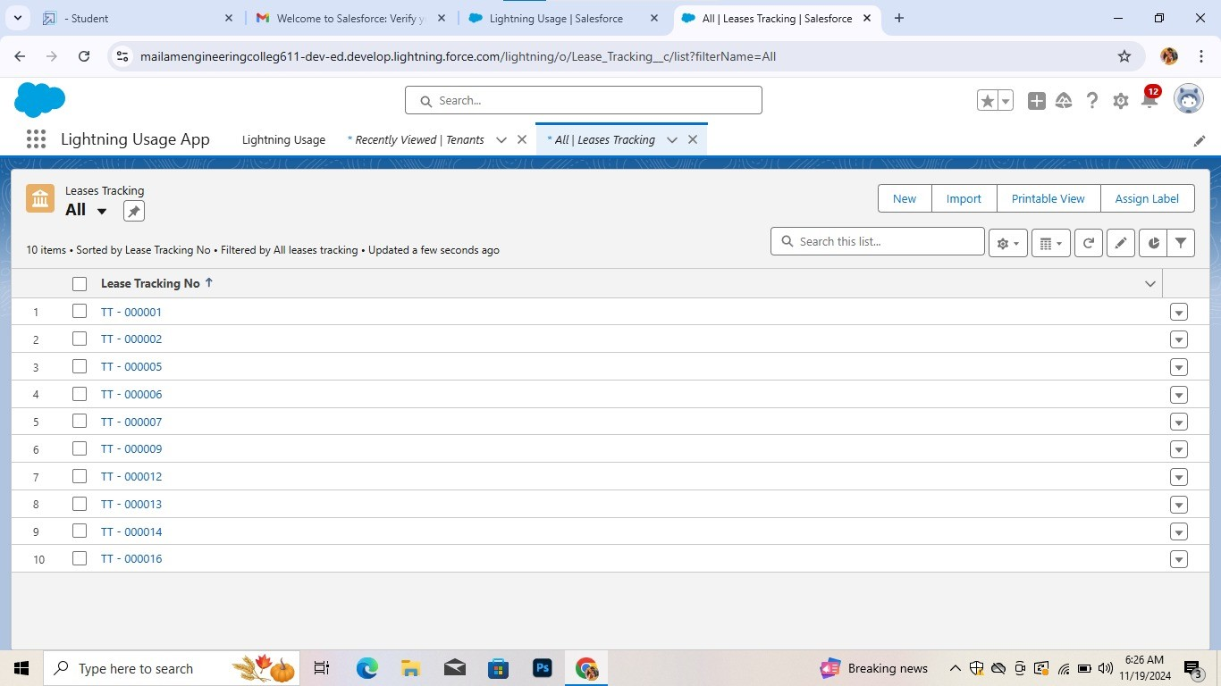

* **Inserting records in tenant issues object:**

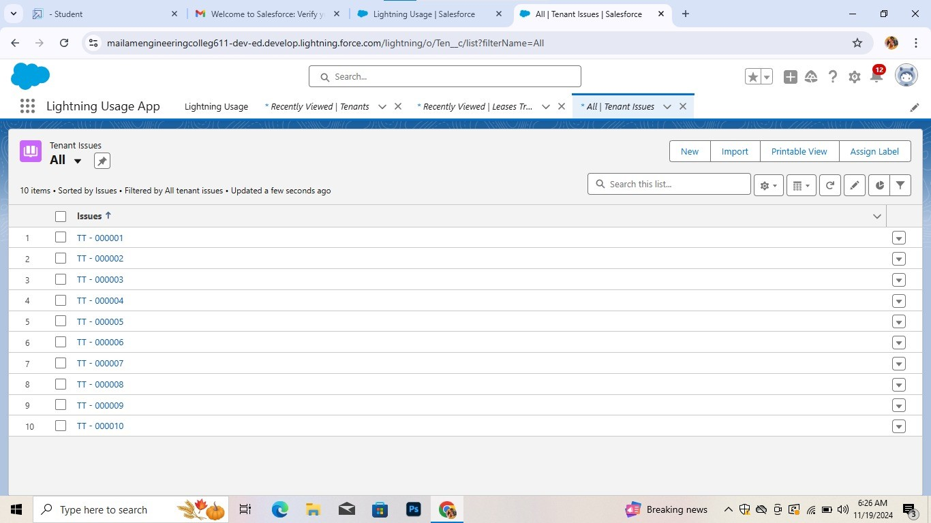

* **Create Flows And Flows For Lease Tracking:**

Below are detailed flows tailored to the key user groups: Mall Administrators, Store Managers, and Customers.

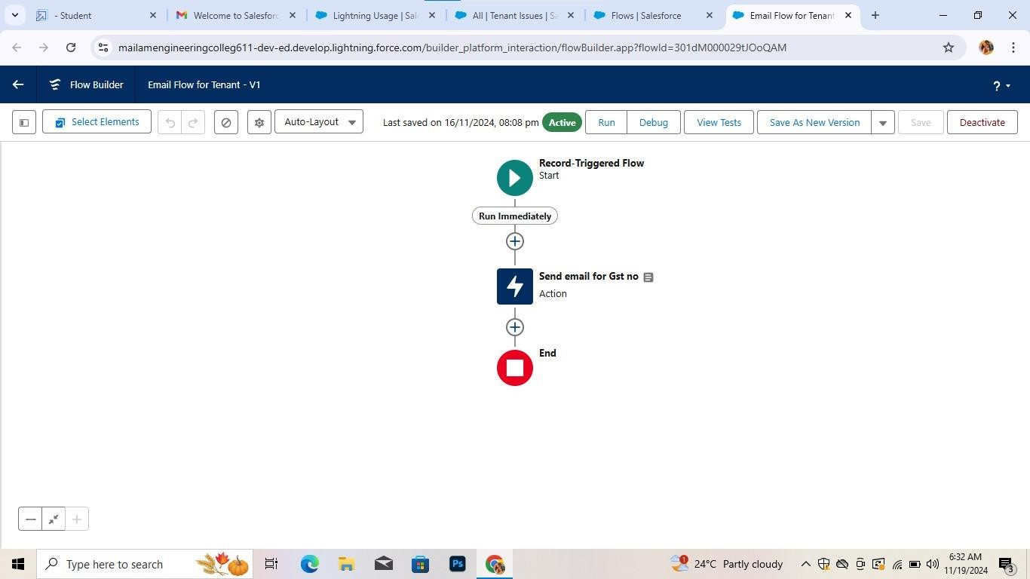

* 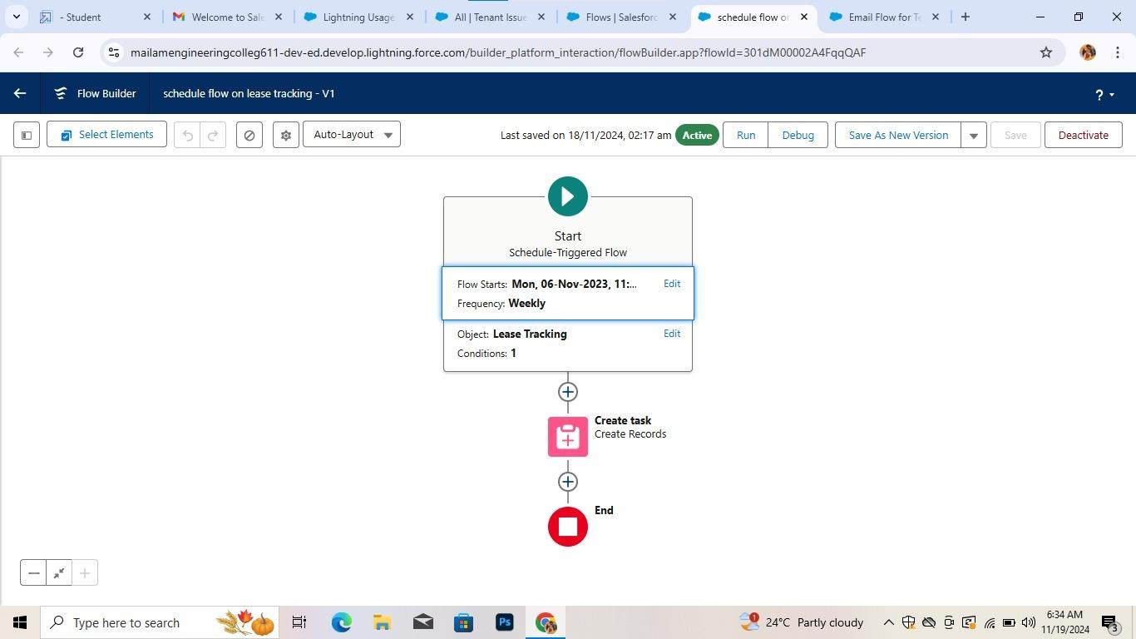
* **Lease tracking trigger:**

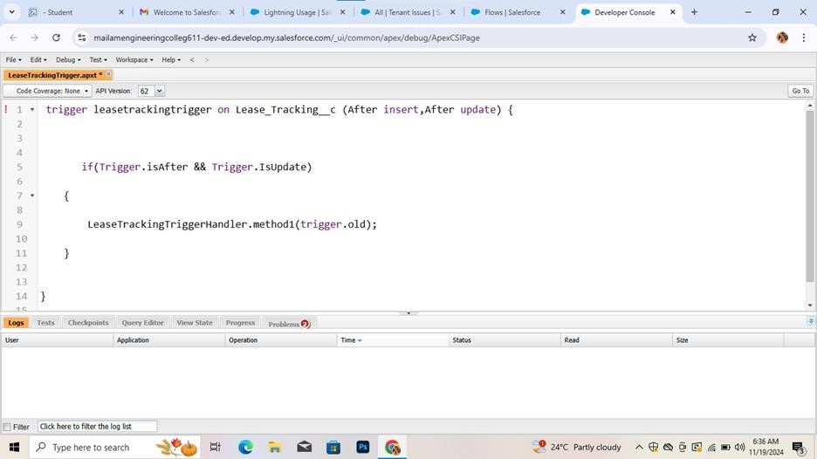

* **Lease tracking trigger handler:**

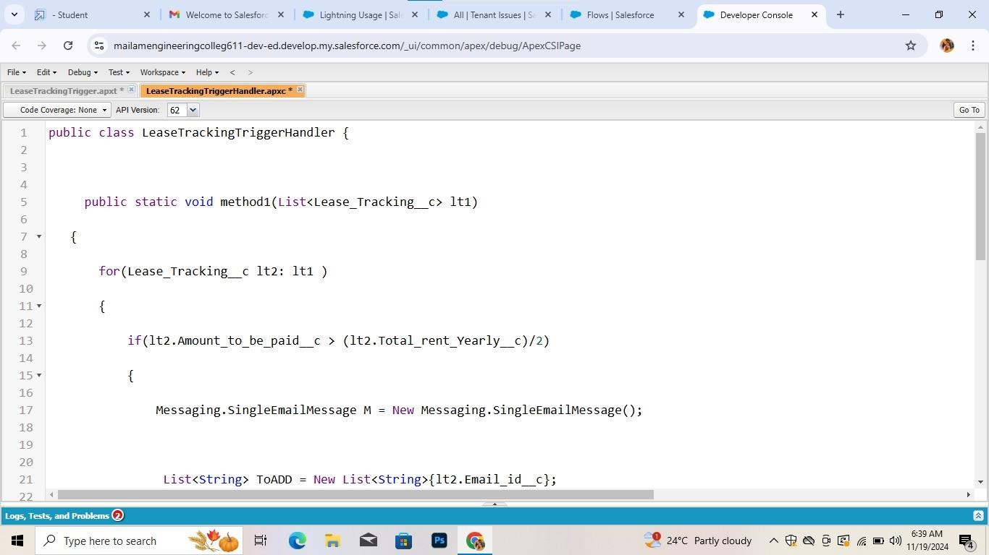

* **Asynchronous apex:**

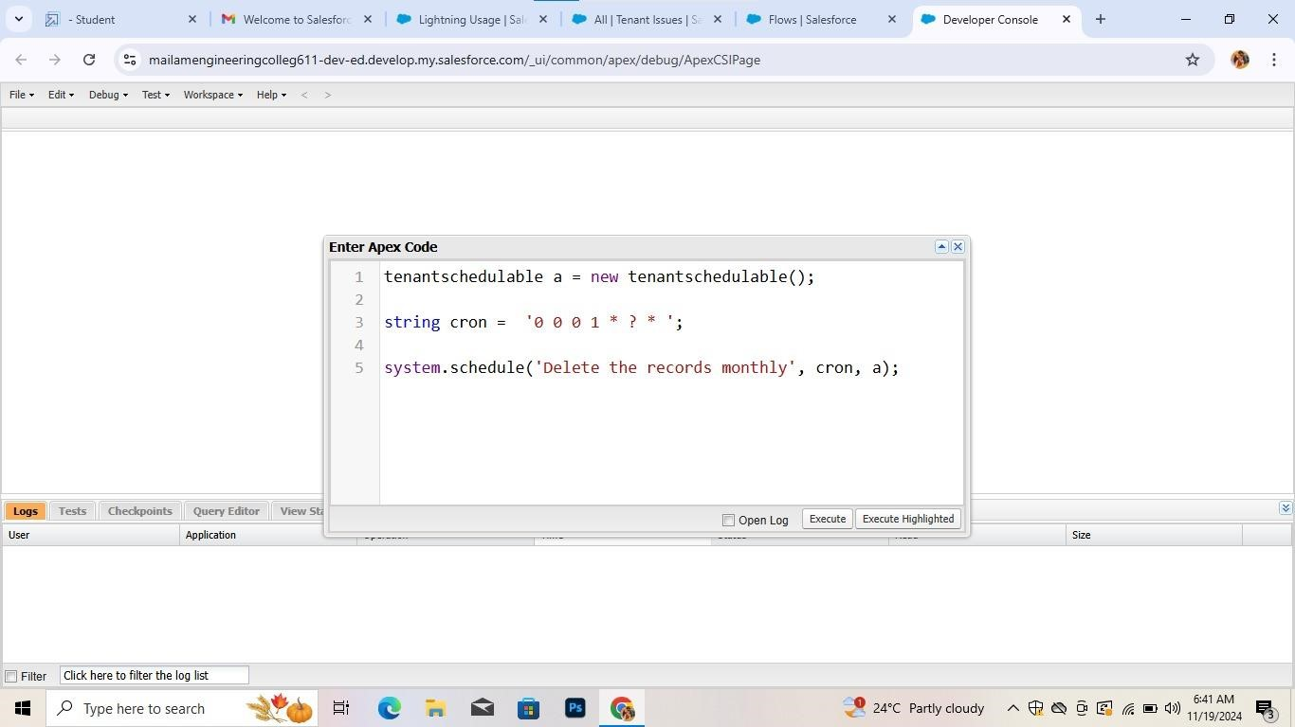

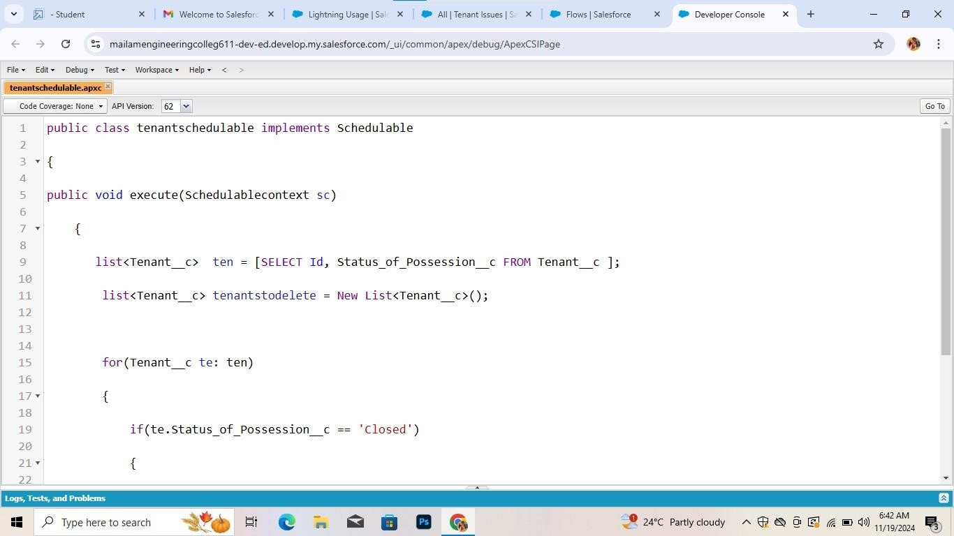

* **Reports:** 
  + **Create A Report of lease Management Records:**

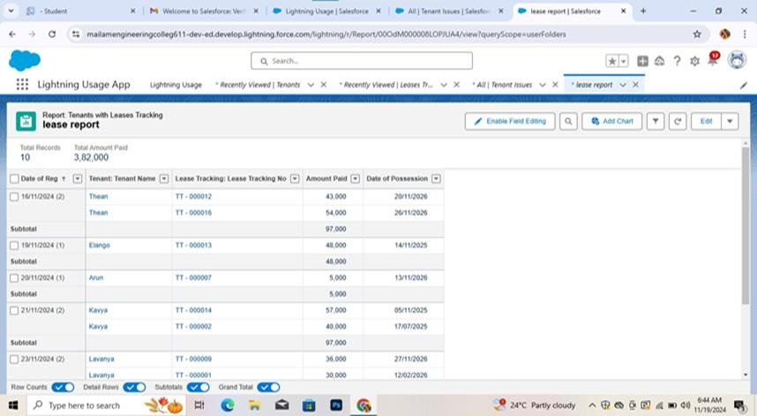

* + **Create a report of Tenant issue:**

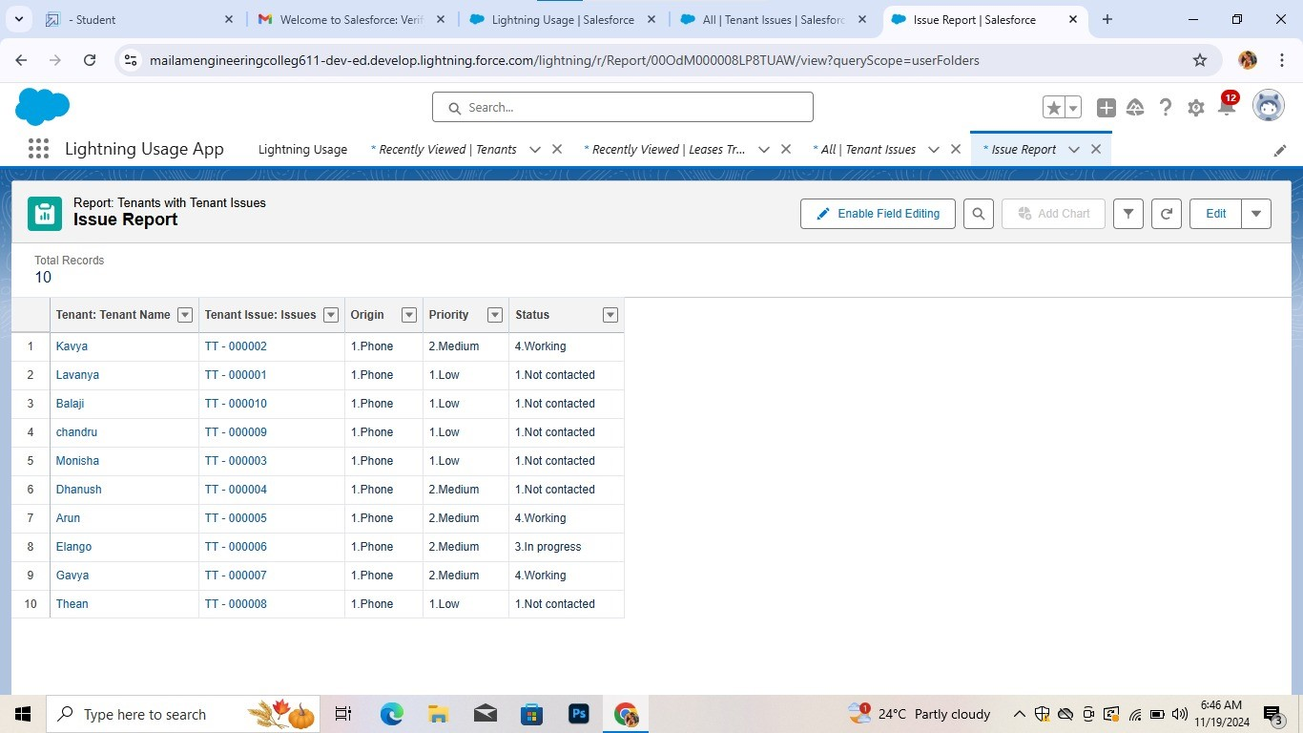

* + **Create A Report on Tenant Records:**

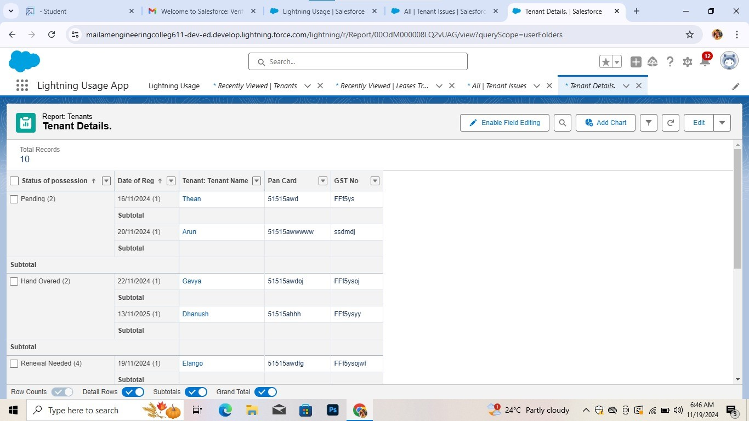

* **Dashboard:**

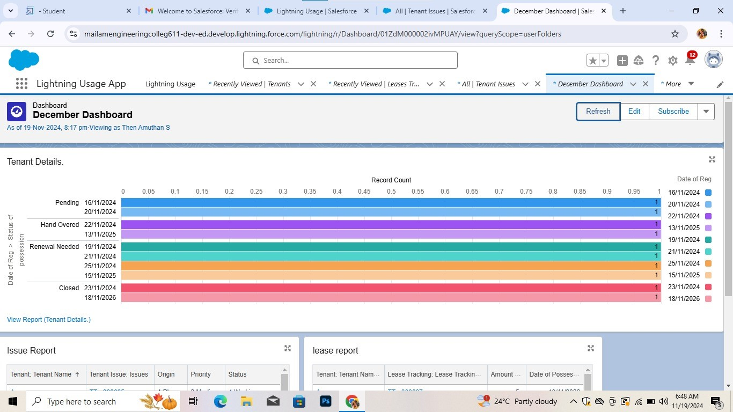

**4.Conclusion:**

In conclusion,the CRM system allows for efficient management of customer relationships through personalized marketing, targeted promotions, loyalty programs, and responsive customer service.

Ultimately, the CRM application not only boosts customer satisfaction and loyalty but also contributes to the mall’s overall growth and operational efficiency, making it an indispensable tool for modern retail management.